# National Plan to End the Abuse and Mistreatment of Older People 2024-2034 – Executive Summary for public consultation

Our vision

All older people feel safe, valued and heard;   
have their rights protected and promoted; and live free from abuse and mistreatment

This National Plan commits to:

Giving a voice to the **diverse needs** and **aspirations** of older people, and advocating for their **rights**

Providing **national leadership** and direction to governments, service providers and community organisations working to **end the abuse and mistreatment of older people**

Delivering **improved governance**, strong systems of **accountability** and robust **evaluation** mechanisms for the implementation of its commitments

**Addressing gaps** and outstanding priorities from the first *National Plan to Respond to the Abuse of Older Australians 2019-2023*.

This National Plan should be considered in conjunction with other Commonwealth, State and Terri-tory Government strategies and reform efforts that either directly or indirectly address the abuse and mistreatment of older people.

## Key principles underpinning the National Plan

The principles identify overarching themes that underpin the entire National Plan and actions to be taken under it by governments, stakeholders and the broader community.

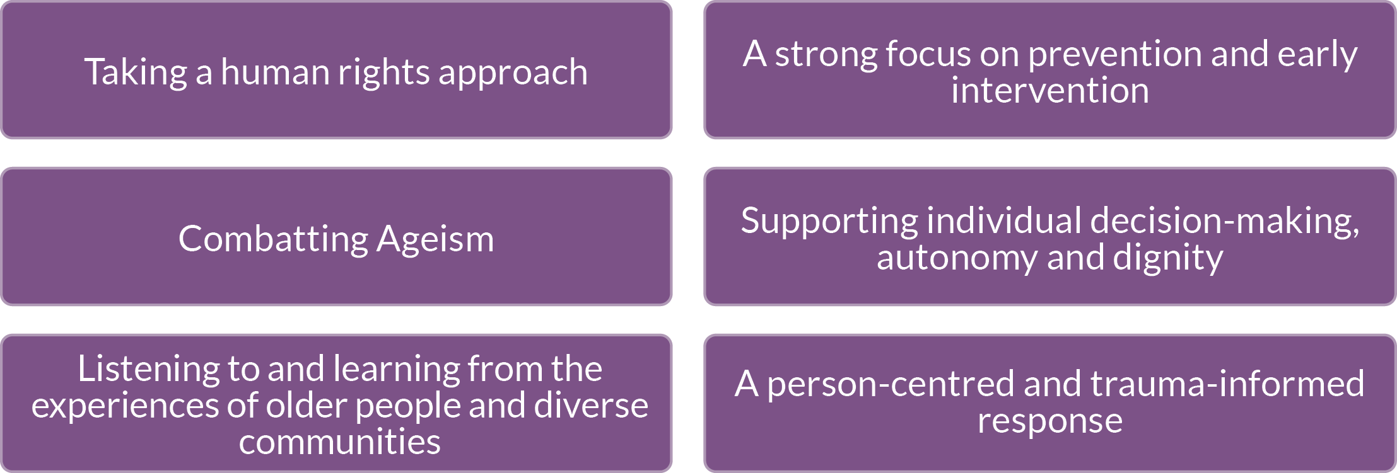

The National Plan is a 10 year strategy with detailed activities to be captured in two, five-year Action Plans.

**The abuse and mistreatment of older people (sometimes referred to as ‘elder abuse’) is a complex health, justice and social issue that can have devastating consequences for older people, their families, and communities. Abuse can be physical, sexual, psychological or emotional, financial or neglect.**

* First Nations people aged 50 years+ are considered older, which is reflective of a number of factors, including lower life expectancy.

The number of people aged 85 years+ will more than triple over the next forty years.

The 65 years+ age group is expected to more than double in the next forty years

The World Health Organisation defines elder abuse as:

**A single or repeated act, or lack of appropriate action, occurring within any relationship where there is an expectation of trust which causes harm or distress to an older person.**

This National Plan acknowledges the **diverse experiences and characteristics** of older individuals and is committed to ending the abuse and mistreatment of **all individuals**.

We recognise that people or groups can experience abuse and mistreatment **differently**, and at different rates, based on  **exposure to discrimination and disadvantage which can intersect with ageism**. An example is people from culturally and linguistically diverse backgrounds. Some individuals and groups can also face more **complex barriers** in **seeking and receiving support**. Abuse and mistreatment among older First Nations people can also be different, and experienced younger and at different rates.

Our efforts are informed by, and responsive to, the **diverse** needs of **communities**. We also seek to harness the **strengths**, and enhance the **protections**, that being part of a **connected community** can provide.

## Focus Areas

These are the high-level priorities which will guide action over the life of this National Plan, and its underpinning Action Plans.

|  |  |  |  |
| --- | --- | --- | --- |
| Focus Area 1 | Focus Area 2 | Focus Area 3 | Focus Area 4 |
| Increase whole of community awareness, education and engagement | Enhance legal frameworks and adult safeguarding responses | Strengthen the capacity and capability of services, including through targeted education and training for professionals | Address gaps in the evidence base and increase collaboration |

|  |  |  |  |
| --- | --- | --- | --- |
| Focus Area 1: Priority actions | Focus Area 2: Priority actions | Focus Area 3: Priority actions | Focus Area 4: Priority actions |
| * 1. Review existing communication resources on ageism and the rights of older people, and the abuse and mistreatment of older people, with a view to developing evidence-based national guidance and communication resources   2. Invest in local community engagement activities to improve understanding and identification of the abuse and mistreatment of older people, and promote strategies to prevent and respond to it   3. Ensure First Nations peoples and other priority groups are involved in the design and delivery of specific communications addressing ageism and the abuse and mistreatment of older people   4. Develop whole-of-society initiatives to combat ageism, foster age-friendly communities and support meaningful social connections, including intergenerational connections   5. Identify, develop and promote abuse prevention initiatives, which should be aimed at upholding older people’s rights and reducing the risk of abuse and mistreatment, and be targeted at the individual, community and system levels   6. Develop targeted, complementary communication campaigns and materials addressing ageism and the abuse and mistreatment of older people and promoting help seeking and pathways to support   7. Continue to make improvements to the national knowledge hub (Compass.info) to enhance diverse user engagement and access to information and support | 1. Continue efforts to achieve greater national consistency in enduring power of attorney laws 2. Continue to raise awareness about the importance of planning ahead for decision making in later years and rights and obligations in relation to enduring instruments 3. Consider recommendations of the Disability Royal Commission relevant to ending the abuse and mistreatment of older people, through government responses in each jurisdiction 4. Strengthen safeguarding frameworks and clarify pathways for abuse and mistreatment to be reported and addressed 5. Explore enhancements to the role of institutions in preventing and responding to financial abuse 6. Continue to implement the Australian Government’s response to the Aged Care Royal Commission, including through delivery of the new Aged Care Act, to protect and enhance the safety, health, wellbeing and quality of life for older people receiving funded aged care services | * 1. Identify best-practice quality and safety standards for specialist elder abuse services, with a view to increasing nationally consistent standards   2. Better target service responses and referral pathways designed to address the needs of people who cause harm to older people, informed by research (refer to Focus Area 4)   3. Act to strengthen the 1800ELDERHelp phone lines, including by improving the capacity of staff to respond to calls and enhancing data collection and reporting   4. Increase equity of access to specialist services by considering service types, geographical distribution and the needs of First Nations peoples and other priority groups, including removing barriers to seeking help and support   5. Strengthen the cultural competency and diversity of specialist service staff and embed a trauma-informed and culturally safe approach into a broad range of professional education resources relevant to preventing and responding to the abuse and mistreatment of older people   6. Improve the coordination, scope and consistency of education for professionals in relevant occupations to ensure they are equipped to identify and respond to ageism, abuse and mistreatment, including in service systems   7. Engage with educational institutions to increase the availability of courses and pathways for individuals who wish to work or develop exper-tise in preventing the abuse and mistreatment of older people, aligned with sector needs | * 1. Develop a national evidence-based prevention framework to guide efforts to end ageism and the abuse and mistreatment of older people   2. Develop a Monitoring and Evaluation Framework for this National Plan, including a staged approach to identifying data gaps and improving data collection and reporting   3. Prioritise and undertake research that addresses gaps in the Australian evidence base on the abuse and mistreatment of older people and ageism, including gaps identified in this National Elder Abuse Prevalence Study   4. Strengthen government, sector (including academia) and community collaboration through investment in dedicated communities of practice, inclusive of the diverse experience of people with lived or living experience of abuse and mistreatment   5. Strengthen government, sector (including academia) and community engagement through investment in key forums such as the Australian Elder Abuse Conference Series |

Monitoring and Evaluation Framework